Modern Multi-Object Tracking Systems
Assignment 3 — Technical Research Report
Visibility Bots Innovation Lab — AI Summer Fellowship 2026 · Computer Vision Engineering Track · Week 3

1. Introduction
Multi-object tracking (MOT) is the task of detecting all objects of interest in every frame of a video and maintaining a consistent identity for each object as it moves across frames. The dominant paradigm in modern MOT is tracking-by-detection: an object detector (e.g. YOLO) locates objects independently in each frame, and a separate tracking algorithm associates those per-frame detections into continuous trajectories over time. This report examines four influential tracking algorithms that represent the major stages of this field's evolution — SORT, DeepSORT, ByteTrack, and BoT-SORT — and compares them on accuracy, speed, and typical applications.

2. SORT (Simple Online and Realtime Tracking)
Introduced by Bewley et al. in 2016, SORT established the tracking-by-detection baseline that nearly every later tracker builds on. It uses only two classical components: a Kalman filter to predict each existing track's next position assuming constant velocity, and the Hungarian algorithm to solve the assignment problem between predicted positions and new detections using Intersection-over-Union (IoU) as the matching cost. SORT deliberately excludes any appearance modeling, deep features, or re-identification — its entire design goal was raw simplicity and speed.
- Strength: extremely fast — the original paper reports an update rate of roughly 260 Hz (tracking only, detection excluded), over 20x faster than contemporary trackers.
- Weakness: because association relies purely on motion and box overlap, SORT loses track identity quickly during occlusion, fast motion, or when two objects cross paths — appearance information would be needed to disambiguate them, which SORT does not have.

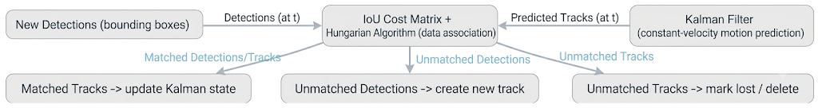

3. DeepSORT
DeepSORT (Wojke, Bewley & Paulus, 2017) directly addresses SORT's biggest weakness by adding an appearance model. A convolutional neural network, trained offline on a large-scale person re-identification dataset, produces a fixed-length embedding vector for each detected object's visual appearance. Association then runs in two stages: a cascade matching step that combines Mahalanobis distance (motion) with cosine similarity between appearance embeddings (prioritizing tracks seen more recently), followed by an IoU-based fallback match for anything left unmatched. This lets DeepSORT re-identify an object even after it has been fully occluded for several frames, since its appearance embedding — not just its last known position — is used to re-acquire it.
- Strength: substantially fewer identity switches than SORT, especially in crowded scenes with frequent occlusion, because appearance survives even when motion prediction fails.
- Weakness: the CNN feature extraction step adds meaningful per-frame compute cost, so DeepSORT is markedly slower than motion-only trackers, particularly as the number of tracked objects grows.
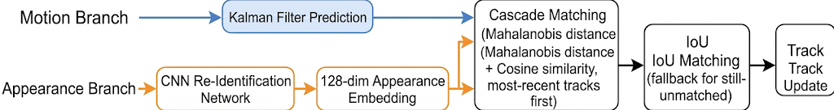

4. ByteTrack
ByteTrack (Zhang et al., 2022) took a different path from DeepSORT: rather than adding appearance features, it fixed a subtler flaw in how prior trackers filtered detections. Most trackers discard any detection box below a confidence threshold before association, assuming low-confidence boxes are background noise. ByteTrack observed that many of those discarded boxes are actually real objects that are simply occluded, blurred, or partially out of frame — and throwing them away fragments trajectories and causes identity switches. Its core contribution, BYTE, is a two-stage association strategy: first match high-confidence detections to existing tracks with IoU, then take the tracks that remain unmatched and try to match them against the previously-discarded low-confidence detections. This recovers genuinely occluded objects without letting low-confidence background noise ever start a new track.
- Strength: matched or beat DeepSORT-level accuracy while remaining a pure motion-and-IoU tracker with no appearance network — giving it DeepSORT-competitive robustness at close to SORT-level speed.
- Weakness: like SORT, it has no true appearance model, so in very dense crowds with many visually similar, closely-overlapping objects it can still misassociate identities that a ReID-based tracker would tell apart.
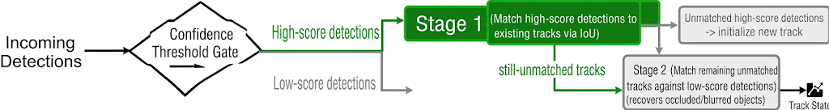

5. BoT-SORT
BoT-SORT (Aharon, Orfaig & Bobrovsky, 2022) builds directly on ByteTrack's association strategy and adds three refinements aimed at the scenarios where ByteTrack still struggles: camera motion compensation (CMC), an improved Kalman filter state vector that more accurately models an object's box size and aspect ratio changes, and an optional ReID appearance branch (BoT-SORT-ReID) that fuses IoU and cosine-similarity costs. CMC is the most distinctive addition: it estimates the camera's own motion between frames (via image registration) and compensates for it before predicting where a track should be — critical for drones, dashcams, or any panning/moving camera, where a static-camera assumption (which SORT, DeepSORT, and ByteTrack all implicitly make) causes the Kalman filter's predictions to drift.
- Strength: the most accurate of the four on the standard MOTChallenge benchmarks (see Section 6), and the only one of the four explicitly designed to handle camera motion.
- Weakness: CMC and the optional ReID branch both add per-frame compute cost on top of ByteTrack's baseline, so BoT-SORT's full-featured configuration trades some speed for its accuracy gains; the plain (non-ReID) variant recovers most of that speed.
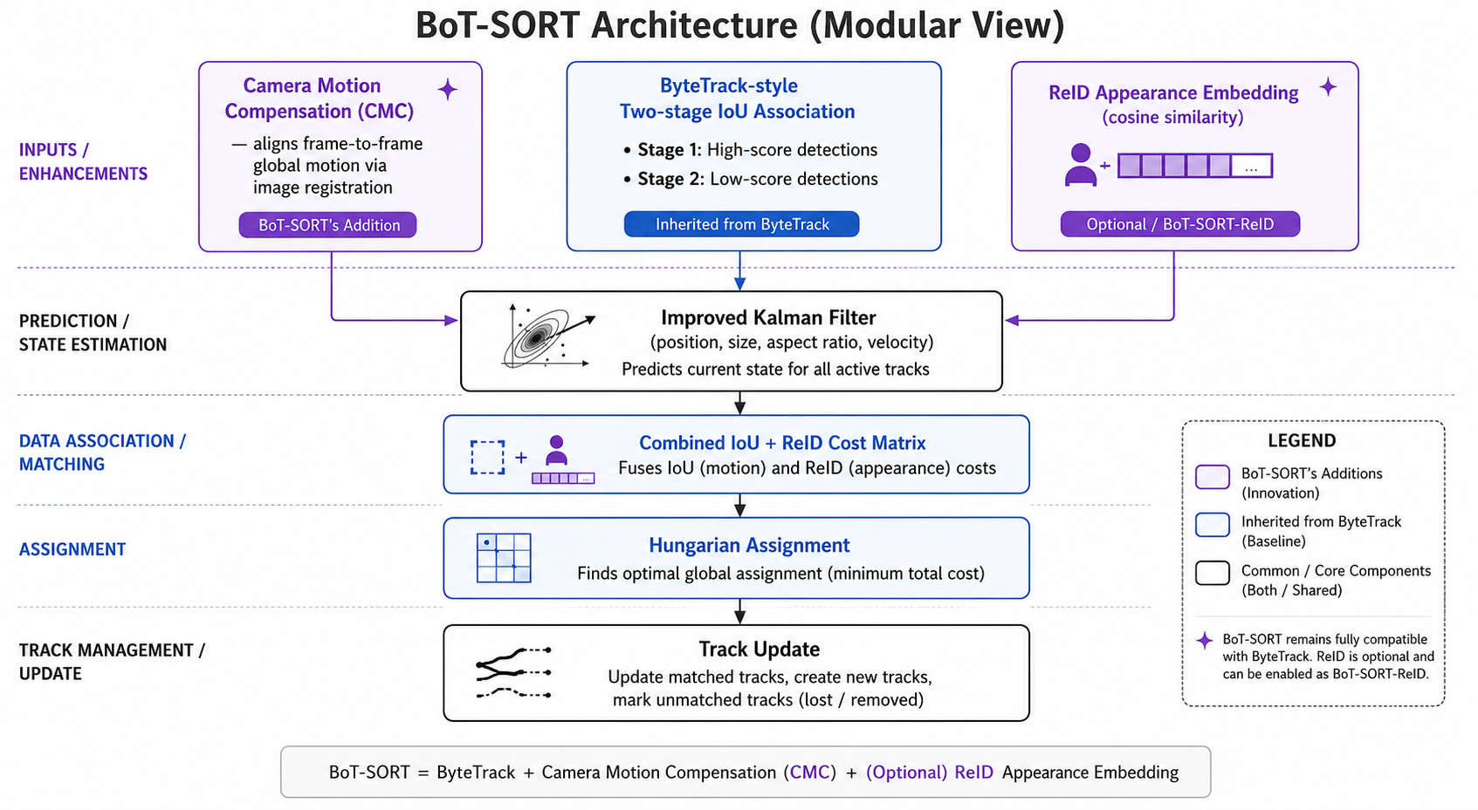

6. Comparative Analysis
Table 1 reports MOT17 test-set benchmark figures for all four trackers. SORT, DeepSORT, and ByteTrack figures are drawn from a single consistent evaluation (Du et al., "StrongSORT: Make DeepSORT Great Again", 2023) so they are directly comparable to one another; BoT-SORT's figures are its own paper's official MOT17 test result (Aharon et al., 2022), evaluated under different settings. Absolute numbers vary noticeably across papers depending on the detector and post-processing used — these should be read as directional evidence of each algorithm's relative strengths, not as absolute ground truth.
Tracker | Year | MOTA ↑ | IDF1 ↑ | HOTA ↑ | ID Switches ↓ | FPS ↑
SORT | 2016 | 42.7 | 45.1 | 36.1 | 4,470 | 57.3
DeepSORT | 2017 | 71.8 | 69.6 | 57.1 | 1,418 | 3.2
ByteTrack | 2022 | 75.7 | 74.9 | 60.9 | 1,347 | 17.5
BoT-SORT-ReID | 2022 | 80.5 | 80.2 | 65.0 | — | —

Accuracy
Accuracy rises monotonically through the sequence SORT → DeepSORT → ByteTrack → BoT-SORT. SORT's lack of appearance modeling and naive detection filtering leaves it far behind on every metric, especially ID switches (4,470 — by far the highest). DeepSORT's appearance embeddings cut ID switches by roughly two-thirds. ByteTrack improves further despite having no appearance model at all, purely by recovering occluded detections that SORT/DeepSORT discard outright. BoT-SORT is the most accurate of the four, combining ByteTrack's association strategy with camera-motion compensation and optional ReID.

Speed
Speed runs in the opposite direction to accuracy for the two appearance-based trackers. SORT is by far the fastest (57.3 FPS reported here; ByteTrack is next (17.5 FPS in this comparison, though its own paper reports 30 FPS on a V100 GPU under different settings), since neither runs a CNN feature extractor per object. DeepSORT is the slowest (3.2 FPS) because its per-object appearance embedding is the dominant cost once more than a handful of objects are being tracked simultaneously. BoT-SORT sits between ByteTrack and DeepSORT: its base configuration (no ReID) is close to ByteTrack's speed, while camera motion compensation and the optional ReID branch each add measurable per-frame overhead.

Applications
- SORT — best where raw speed matters more than robustness and occlusion is rare: early-stage prototyping, simple counting on uncluttered scenes, embedded/edge devices with very limited compute.
- DeepSORT — pedestrian tracking in crowded scenes where objects are frequently and fully occluded for multiple seconds, e.g. retail foot-traffic analytics, dense crowd surveillance, sports broadcast tracking of specific players.
- ByteTrack — the default general-purpose choice for most real-time production systems (traffic and vehicle counting, drone footage, general CCTV analytics) where a strong balance of speed and accuracy is needed without the compute cost of an appearance model.
- BoT-SORT — deployments needing the highest achievable accuracy and/or a moving camera: PTZ or drone-mounted surveillance, dashcams, and dense-crowd scenarios (MOT20-style) where both occlusion and camera motion are present simultaneously.

7. Conclusion
The four algorithms surveyed here trace a clear line of reasoning in multi-object tracking research: SORT proved that a minimal motion-only tracker could be competitive; DeepSORT showed that appearance information solves the occlusion problem SORT could not, at a real speed cost; ByteTrack showed that a large part of that same problem could be solved for free by simply not discarding low-confidence detections, avoiding the CNN overhead entirely; and BoT-SORT showed that ByteTrack's association strategy could be combined with camera motion compensation and optional appearance fusion to push accuracy further still, at a smaller, more controllable speed cost than DeepSORT's full ReID pipeline. There is no single best tracker across every deployment — the right choice depends on whether the constraint is raw speed (SORT), heavy occlusion in a static scene (DeepSORT), balanced real-time general use (ByteTrack), or maximum accuracy with a possibly-moving camera (BoT-SORT).

